Graphing

Basic Graphing Requirements

1. Title for graph
2. Axes labels with units
3. Legend ONLY if you have more than one line
4. NO data labels

Use the website: <https://nces.ed.gov/nceskids/createagraph/>

If data involves time, then it is a line graph 99% of the time.

A bar graph is used to show separate entities: plants grown in different conditions, two beakers with different changes in temperature, etc.

Screen One: Select Graph Type

Screen Two (line graph): Design

Leave background color white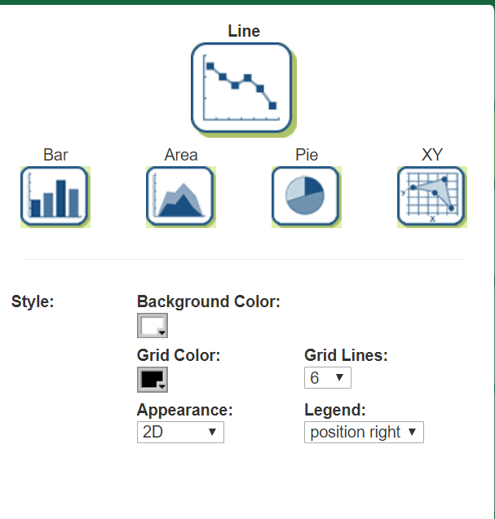

Leave grid color black

Use 2D

If you only have 1 line to graph (one set of ranges or y or outputs), then change legend to -no legend-

If you have 2 lines to graphs, then leave legend on "position right"

Screen 3: DATA

Create a graph title: 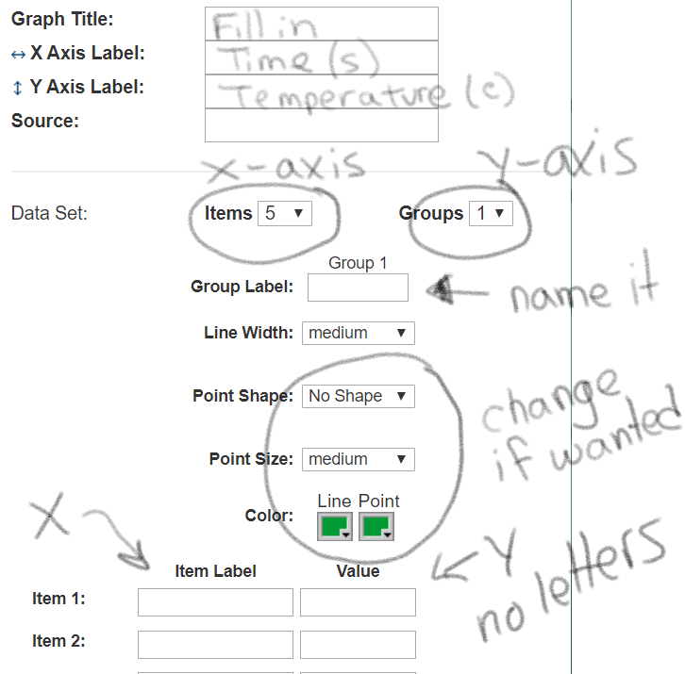

Ex. Change in Temperature Over Time

Create axis labels with unit in parentheses

Items are your X values: change the item # to the number of data points in your data table

Groups are your Y values: change the item # to the number of data points in your data table

You can change the shape of points, size of points, and color of line

Fill in data. You CANNOT input letters into the value column, only numbers (values)

Screen 4: Labels- SELECT NO at top of box

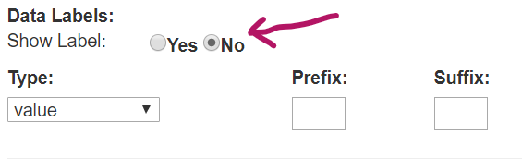

Screen 5: Preview

Check out the graph, how does it look?

Click update if your changes didn't show up.

Common Issues:

No line shows up: check data to make sure you didn't put any letters in value boxes

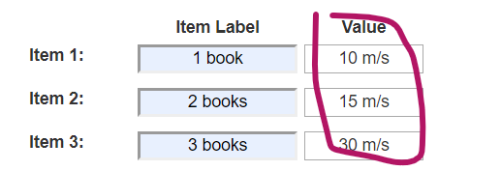

Line is at the very top of grid or bottom: adjust min-value and max-value on Data Screen to help get line into center of graph

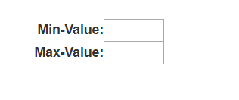

Line ends before end of grid: make sure you only have a box for each data point and no empty boxes on DATA screen

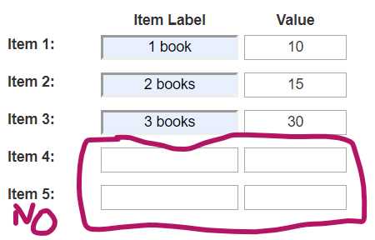

Example For Temperature Over Time for Two Containers of Ice and Water

